CANDYMAN

Link to PPT
Need to add this once I upload onto site

Big Idea: Numbers to 1o represent quantities that can be decomposed; Addition and subtraction with numbers can be modelled concretely, pictorially, and symbolically to develop computational fluency.

Curricular Competencies:
Reasoning and Analyzing
- use reasoning to explore and make connections
- estimating reasonably
- developing mental math strategies and abilities to make sense of quantities
- model mathematics in contextualized experiences and explore the utility of mathematics as a tool for solving real-life problems
Understanding and Solving
- visualizing to explore mathematical concepts
- develop, demonstrate and apply mathematical understanding through play, inquiry and problem solving.
- develop and use multiple strategies to engage in problem solving
Communicating and Representing
- communicate mathematical thinking in many ways
- explain and justify
- represent mathematical ideas in concrete, pictorial, and symbolic forms
Connecting and Reflecting
- reflect on mathematical thinking
- connect mathematical concepts to each other

Content: number concepts to 10; addition and subtraction to 10; estimating sums and differences; using various strategies; using different models such as a number line and ten frames; using addition in problem-based situations.

ACT ONE:

What did you notice? | What do you wonder?

FOCUS QUESTION:

How many were there in all?

Estimating:

A too low estimate: | A too high estimate:

ACT TWO:

What else do you need to know to answer the question? What information would you like to have?
e.g., How many of each different colour are there?

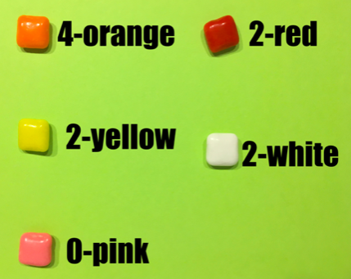

Provide students with materials they can use to model the problem. These could include:
- ten-frames both empty to be used with counters and paper ten frames ones with dots that can be used represent the different addends
- unifix cubes (be sure not to provide all the same colours and those in the video)
- counters all the same colour (e.g., pebbles)
- coloured markers, pencil crayons, and/or crayons
- numbers (e.g., wooden, plastic, dice)
- number lines with and without numbers – e.g., open number lines
- mini-clipboards with paper and pencils

Guiding questions for the teacher to consider:
- How are students engaging in the problem solving?
- What do they notice? What do they wonder?
- Are the students able to ask questions?
- Once the students engage with problem, are they able to mathematically model the situation?
  - What tools/model to they select to represent the question? (e.g. ten frames, number lines, hundred’s chart, pictures, counters, equations)
  - Are they able to think abstractly and use different coloured or all the same colour counters to represent the different smarties?
  - Can they represent their concrete models pictorially?
  - Do they use labels to help communicate ideas?
- Are the students able to orally explain their thinking?
- When different strategies have been shared, are students able to make connections between similar strategies and the representations used?

What STRATEGIES are being used?
Make note of who uses which strategy and take pictures or video so that these can be shared with the class as a whole.

  - Who counted all?
    - Do students have one-to-one correspondence? If they make a mistake do they catch themselves and self-correct?

  - Who counted on?
    - Are students counting on from the largest quantity?

  - Who adds in chunks?
e.g., 4 + 2 + 2 + 2 =

  - Who made friendly tens?
e.g., 4 + (2 + 2 + 2 ) =
4 + 6 =

  - doubles/near doubles strategy?
e.g., 4 + (2 + 2) + 2 =
(4 + 4) + 2 =
8 + 2 = 10

ACT THREE:
Gather the students as a whole class and share photos and videos taken via the projector with the class. Ask students to orally explain the strategies they used. Highlight, compare and connect the strategies students used.

Sharing
- Build a class anchor chart with the different strategies students used.

REVEAL the answer! – ACT THREE

Summarize the learning:

Self-Reflection:
Strengths: What worked (What strategies did you use to work toward a solution)?
Stretches: What was difficult?
Next steps: What would you do differently next time? Was anyone inspired by someone else’s strategy?

Moving Forward:
Continue to explore different combinations of quantities to 10.

