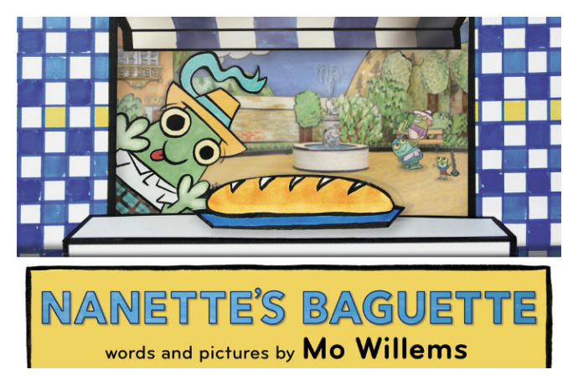Nanette’s Baguette

Big Idea: Subtraction with numbers to 20 can be modelled concretely, pictorially, and symbolically to develop computational fluency.

Curricular Competencies:
Reasoning and Analyzing
- use reasoning to explore and make connections
- estimating reasonably
- developing mental math strategies and abilities to make sense of quantities
- model mathematics in contextualized experiences and explore the utility of mathematics as a tool for solving real-life problems

Understanding and Solving
- visualizing to explore mathematical concepts
- develop, demonstrate and apply mathematical understanding through play, inquiry and problem solving.
- develop and use multiple strategies to engage in problem solving

Communicating and Representing
- communicate mathematical thinking in many ways
- explain and justify
- represent mathematical ideas in concrete, pictorial, and symbolic forms

Connecting and Reflecting
- reflect on mathematical thinking
- connect mathematical concepts to each other

Content: Subtraction to 20

ACT ONE:

What did you notice? | What do you wonder?

FOCUS QUESTION:

How much of the baguette was left?

Estimating:

A too low estimate: | A too high estimate:

ACT TWO:

What else do you need to know to answer the question? What information would you like to have?
e.g., How many cubes long is the part of the baguette that Nanette took?

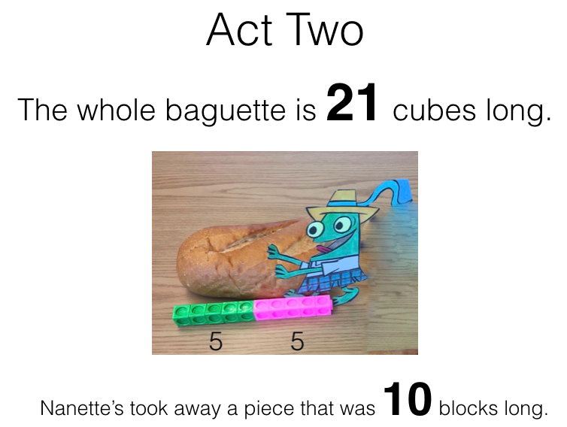

Provide students with materials they can use to model the problem. These could include:
- ten-frames both empty to be used with counters and paper ten frames ones with dots that can be used represent the different addends
- unifix cubes
- counters all the same colour (e.g., pebbles)
- numbers (e.g., wooden, plastic, dice)
- hundreds charts with highlighters
- number lines with and without numbers – e.g., open number lines
- mini-clipboards with paper and pencils

Guiding questions for the teacher to consider:
- How are students engaging in the problem solving?
- What do they notice? What do they wonder?
- Are the students able to ask questions?
- Once the students engage with problem, are they able to mathematically model the situation?
  - What tools/model to they select to represent the question? (e.g. ten frames, number lines, hundred’s chart, pictures, counters, equations)
  - Do they use labels to help communicate ideas?
- Are the students able to orally explain their thinking?
- When different strategies have been shared, are students able to make connections between similar strategies and the representations used?

What STRATEGIES are being used?
Make note of who uses which strategy and take pictures or video so that these can be shared with the class as a whole.

  - Who added up?
    - Did the student add up by ones?
    - Or add up in larger chunks?
    - Added 10 to get to 20 and added 1 more?
    - Uses a known fact (e.g., 11 + 10 = 21)?

  - Who counted back (also known as removal)?
    - Who counted back by ones?
    - Who counted back in chunks?
    - Who chose to think about 21 and 2 tens and 1 one
e.g., 21 - 10 =
(20 + 1) – 10 =
(20 – 10) + 1= 11
10 + 1 = 10

ACT THREE:
Gather the students as a whole class and share photos and videos taken via the projector with the class. Ask students to orally explain the strategies they used. Highlight, compare and ask questions to help the students connect the strategies used.

REVEAL the answer! – ACT THREE

Summarize the learning:

Self-Reflection:
Strengths: What worked (What strategies did you use to work toward a solution)?
Stretches: What was difficult?
Next steps: What would you do differently next time? Was anyone inspired by someone else’s strategy?

Moving Forward:
Continue to explore different combinations of quantities to 20.

