RED | YELLOW
SHAKE AND SPILL
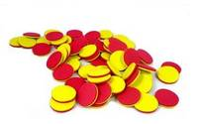

Circle the quantity that is bigger!

