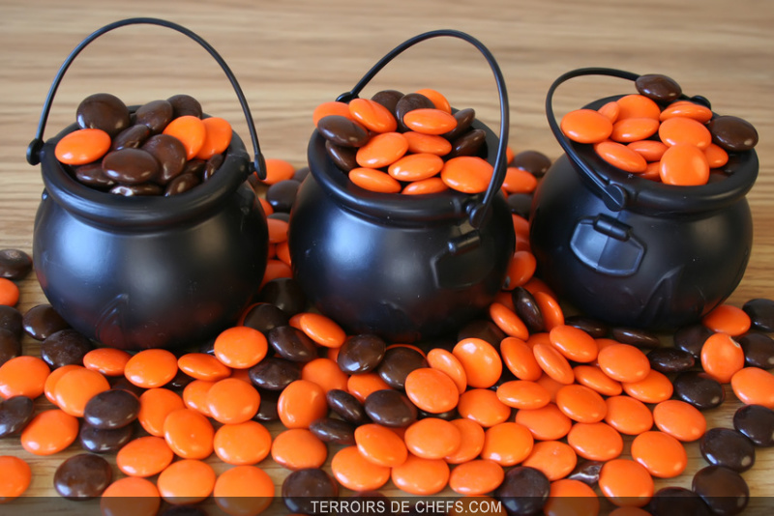
Name______________________________

Guess how many Smarties are in your box ____
My box has _____ Smarties
Here is a graph of my box:
Orange | Brown

Ways to make 10

_________ orange and _________ brown is 10
_________ orange and _________ brown is 10
_________ orange and _________ brown is 10
_________ orange and _________ brown is 10
_________ orange and _________ brown is 10
_________ orange and _________ brown is 10
_________ orange and _________ brown is 10

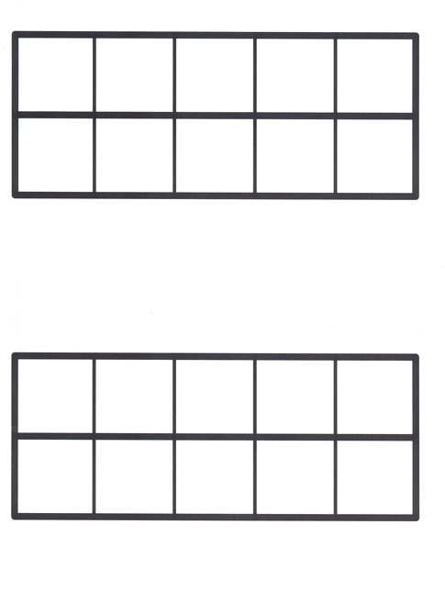
___________ + _____________ = _______________
___________ + _____________ = _______________
___________ + _____________ = _______________
___________ + _____________ = _______________
___________ + _____________ = _______________
___________ + _____________ = _______________
These are the patterns I made:

