Name: ________________ Date: ________________

Which One Doesn’t Belong?
Image from Berkeley Everett retrieved from http://www.fractiontalks.com/

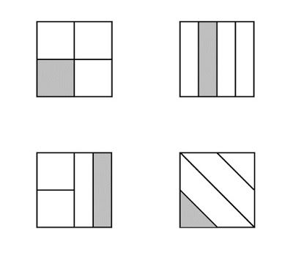
Take a few minutes to record what you notice about each of the images.

Which one doesn’t belong? Explain your reasoning…

